Inspirational Material

1. Interview with Tommy Refenes of Team Meat. He coded ‘Super Meat Boy’ and appeared in ‘Indie Game: The Movie’. He is currently working on ‘Mew-Genics!’ <http://www.youtube.com/watch?v=nCpW0WbCVzQ&list=WLCEC91948B914B694>
2. Interview with Jonathan Blow. He coded and designed ‘Braid’ and appeared in ‘Indie Game: The Movie’. He is currently working on ‘The Witness’. <http://www.youtube.com/watch?v=HTumujaqEe8&list=WLCEC91948B914B694>
3. I do not want my coding to be like the Jak 2 port for Psp Vita. This ruined the game experience and made the game unplayable. 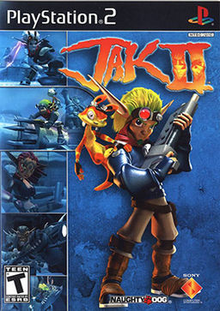
4. Tommy Refenes is one of my biggest inspirations for programming. By himself, he designed the whole control system of Super Meat Boy and made the game enjoyable because of the amazing feel of the controls.